**1. Your report should be written in English. The report should include the code (with comments or notes), the resulted figure (or print-screen), and a short discussion on the result if necessary.**

**2. Upload: .m file, .fig file and .doc report**

**3. Pack all the above files and send to 1315480535@qq.com**

**4. The format of pack name: LabX_ID_Name.zip, X is the experiment number.**

**5. Deadline: Thursday in Next week.**

**Complete the following tasks:**

1. Generate random process:（序列长度1000，eg2.9）

(1) Generate a random process y[n]=x1[n]+sin(x2[n]), where both x1[n] and x2[n] following Gaussian distribution with mean of 0 and variance of 1.（x1[n]和x1[n]均值0和方差1的高斯分布）**randn**

(2) Calculate the mean and variance of y[n]. Is it ergodic and stationary?（计算y[n]的均值和方差，是否为各态历经性和平稳的）

(3) Plot the spectrum and auto-correlation of y[n]. Note that y[n] is discrete-time sequence. (Using the code given in the slides)(画出频谱和自相关，用ppt中的代码)

2. Analog modulation. Sampling rate Fs=1500Hz.（模拟调制采样率1500Hz）

(1)The message signal is m(t)=sin(2*pi*t). Modulate it using DSB-AM, and **USSB_AM,** where fc=20Hz. For AM, Ac=1. For USSB_AM, Ac=sqrt(2). Calculate the power of the modulated signal and message signal. Plot the modulated signal and the spectrum.（两种调制方式，计算消息信号和调制信号的功率，并绘制调制信号和其频谱）

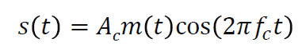

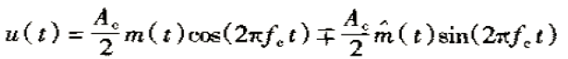

(2) Demodulate the above signals. What is the pass band of **the low-pass filter** for AM and USSB_AM?. Plot the demodulated signal and the spectrum.（解调上述信号，两种低通滤波调制方式的通带是多少？画出解调信号和其频谱）

(3) Add the thermal noise with N0=0.0005, plot the modulated signal and demodulated signal. （时域）（加噪声，方式按照ppt）（画调制信号和解调信号）

(4) What is the disadvantage if we apply a low-pass filter with a band much wider than necessary? Try to support your statements with simulation results.（如果我们使用带比必要的宽得多的低通过滤器，缺点是什么）